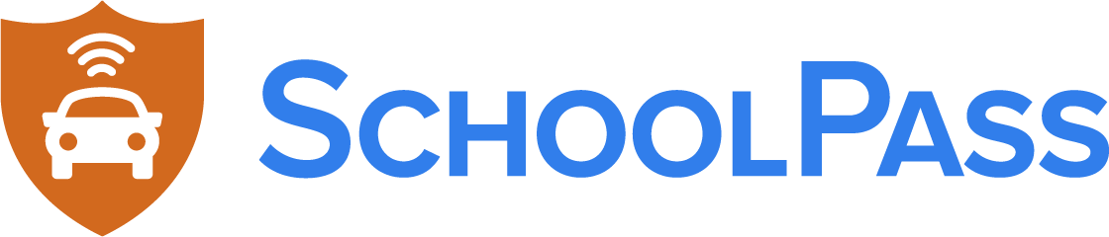

Dismissal Safety & Efficiency Report Card

SchoolPass works with PK-12 schools across the country to strengthen their dismissal safety and operations through perimeter security, carline automation and bus management.

For a limited time, we are offering a complimentary school dismissal safety & efficiency review to compare you to established best practices at schools across the United States. The sample below highlights the core areas evaluated, which we will customize from your school’s review and send back to you within a few short days. As a thank you once you complete the review, we will send you a $10 Starbucks gift card. Take My Five Minute Review!

Category | School Result vs. Best Practice | Key Improvement Opportunity
Total Grade | 75%  C | Front Office Efficiency & Perimeter Security
Efficiency Grade | 67%  D+ | Reduce time spent in front office processing dismissal changes. Typically, a 500-student school spends 900 hours or more processing these changes.
Safety Grade | 75%  C | Implement 24/7 automated campus vehicle tracking and classification (staff/parent/student driver/unknown) and triggered alerts for “bad actors” (non-custodial parents, terminated staff, expelled students).
Customer Service Grade | 81%  B- | Remove teachers from dismissal plan change communication loops to yield instructional and lesson-planning time.

Want to see how you measure up? Take My Five Minute Review and we will customize a Report Card for you. And you will get a $10 gift card once you complete the review.

